**Flightdocs Product Development Technical Interview – QA Automation**

The tests are split into 4 files: filter_and_add.js, delete_items.js, compare_ListV.js, and compare_GridV.js. In order to run each file, go to conf.js and uncomment the file to be tested.

**Filter and Add Items to Cart.**

* When the user clicks on Summer dresses from the catalog tab, the page keeps loading. The targeted page does not charge in both views (Grid-List).

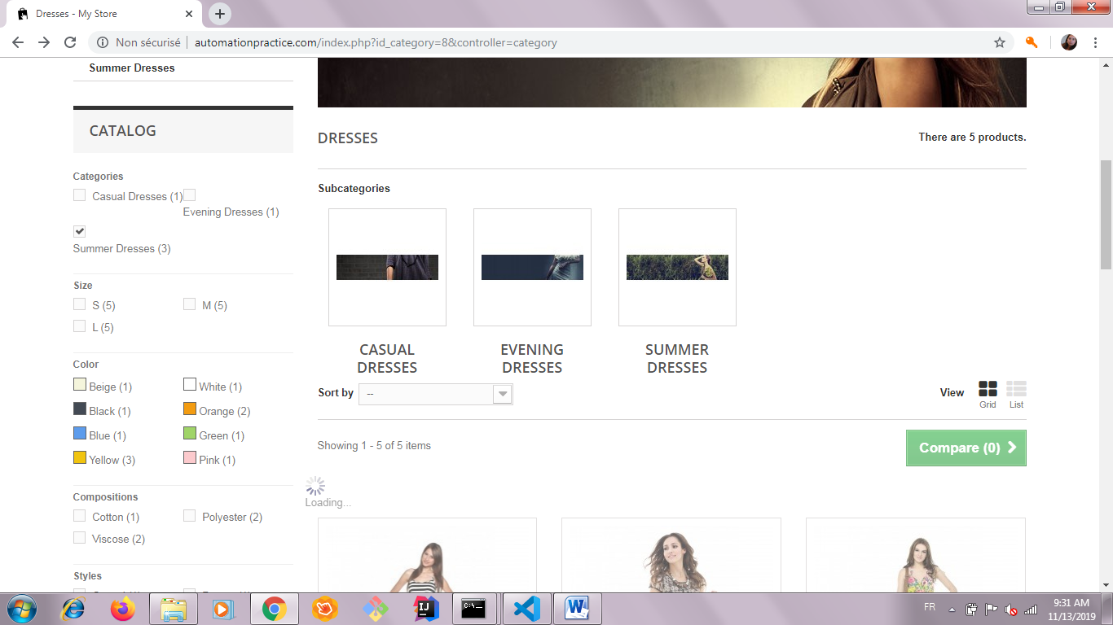

* When the user selects the yellow option from the “Color” section within the catalog tab, the user is not brought to the desired page in both views (Grid-List).

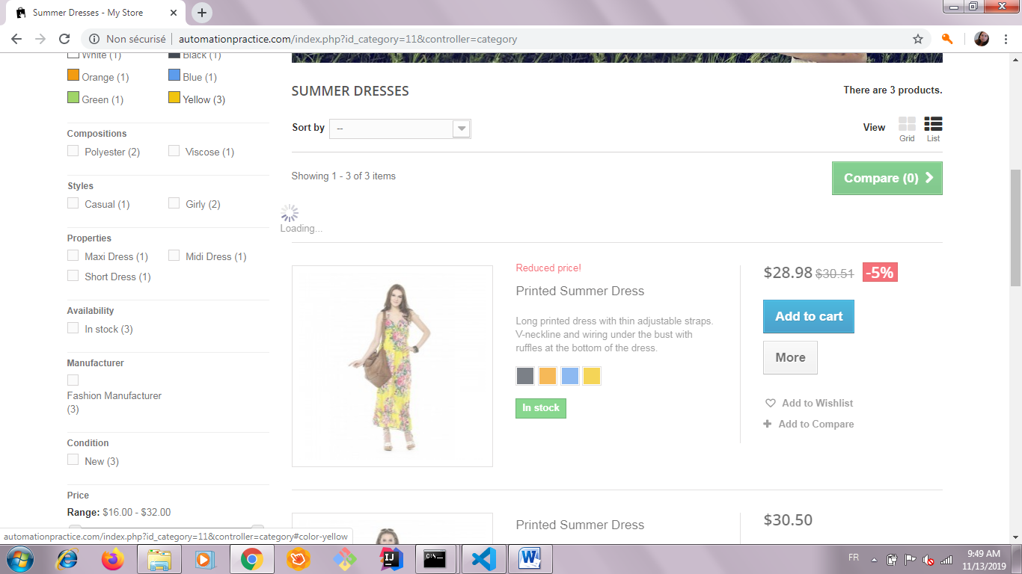

* In the dresses page, when the user selects any criteria within any section in the “Catalog” tab, the page does not load after the selection is made. It stays on loading mode in both views (Grid-List) – As show in the example screenshot above-.
* In the T-shirts page, when a criterion is chosen in the “Catalog” tab, the page stays on loading mode in both views (Grid-List)-.
* Shopping Cart Summary:

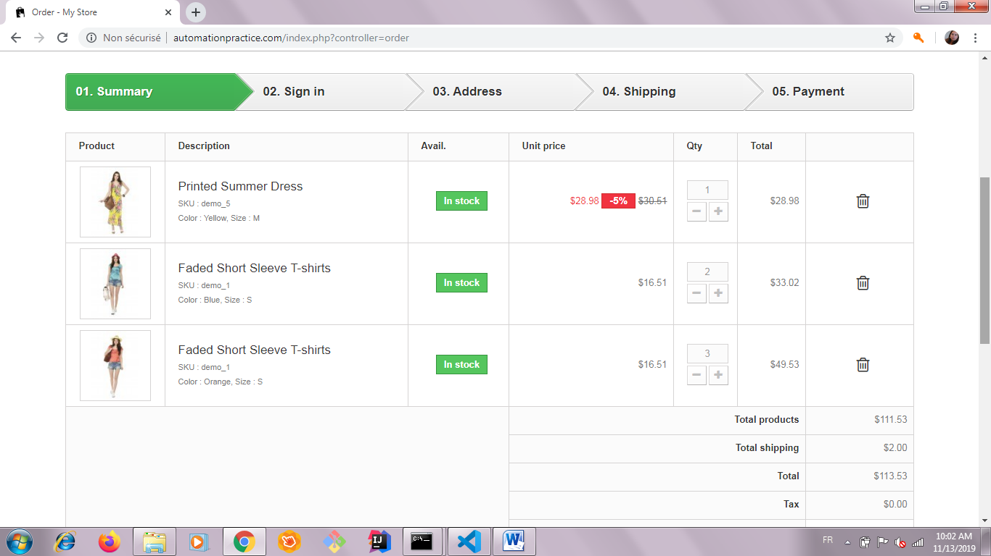

* The output for test 8 – Change quantity to 2 via entering text input, change the color to blue, change the size to small and add the item to cart – when the user maximizes the size of the window, it gives error index out of band for 0. Otherwise, the test does not fail.
* Test terminal output:

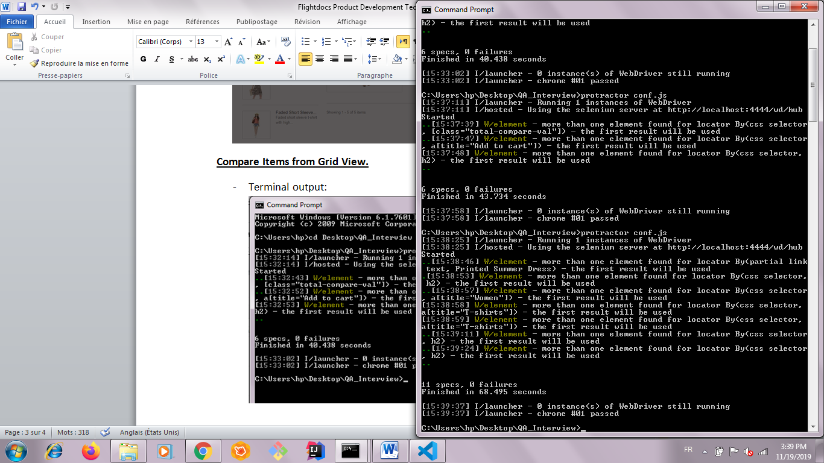

**Delete Items.**

* Manual testing for removing items from cart output:

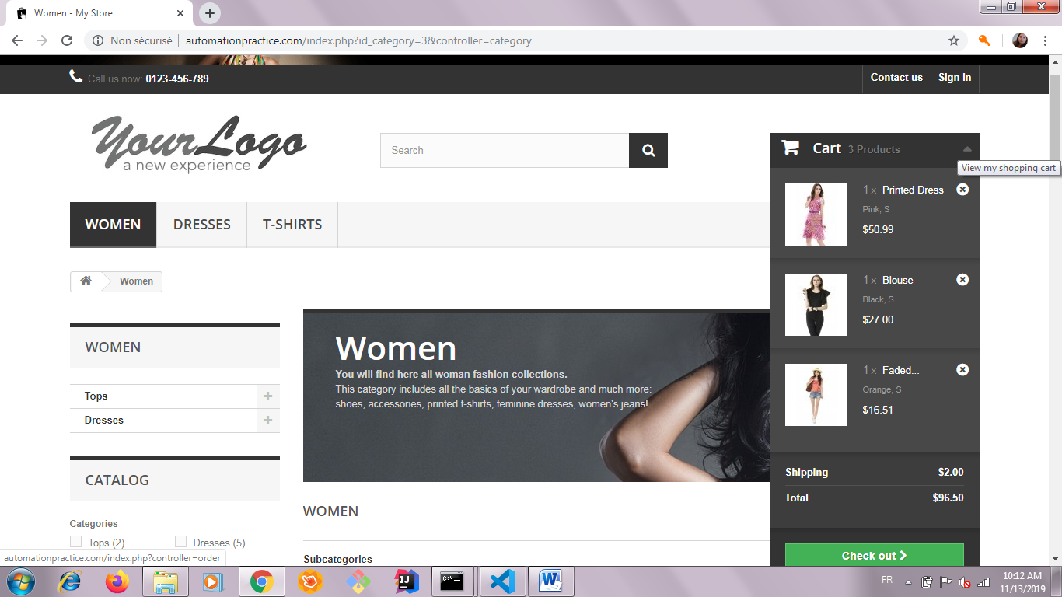 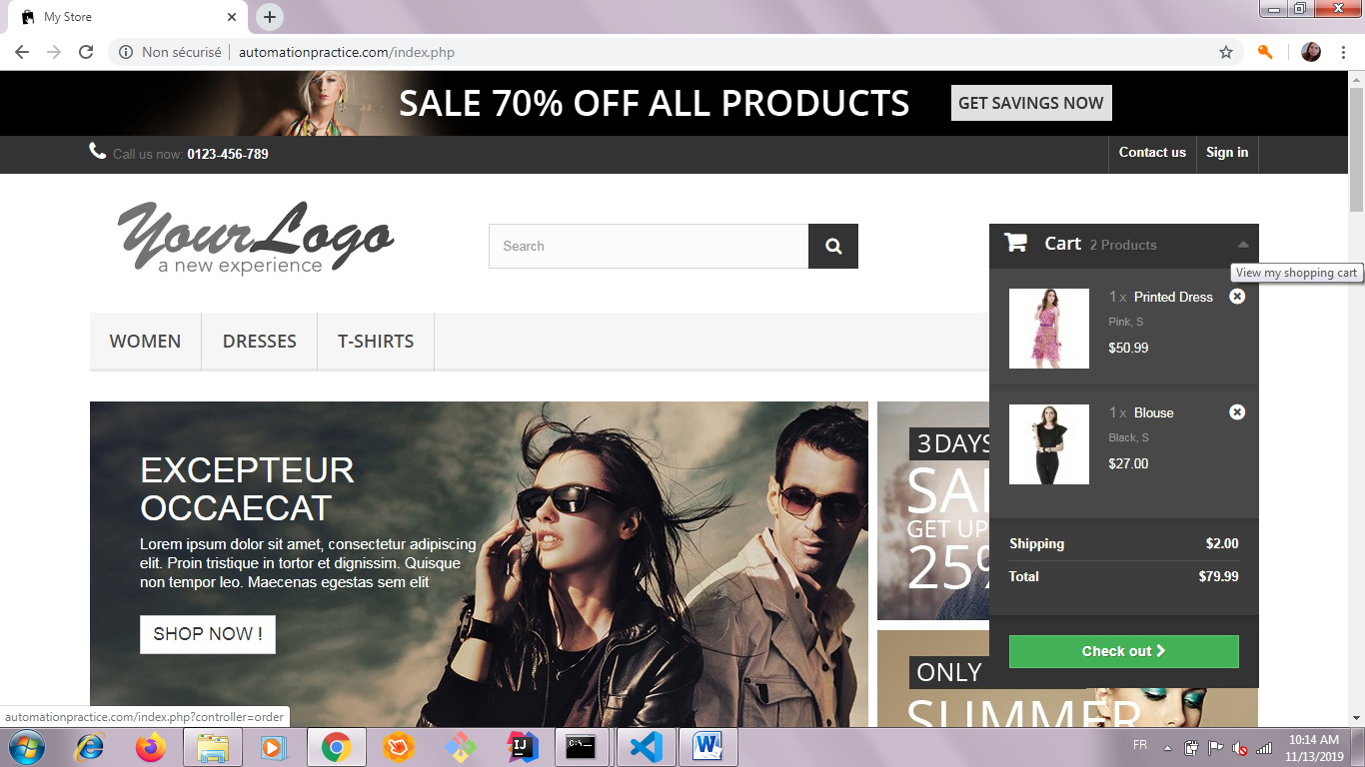

* Depending on the size of the screen, the word “products” appears or does not appear next to the number of items in the Cart dropdown.
* When the user clicks the ‘x’ button next to an item to remove it, the item is removed from the cart. However, if the cart contains two similar items and the user wants to remove one of them, the count does not go down by one; it deletes the whole entry.
* Test terminal output:

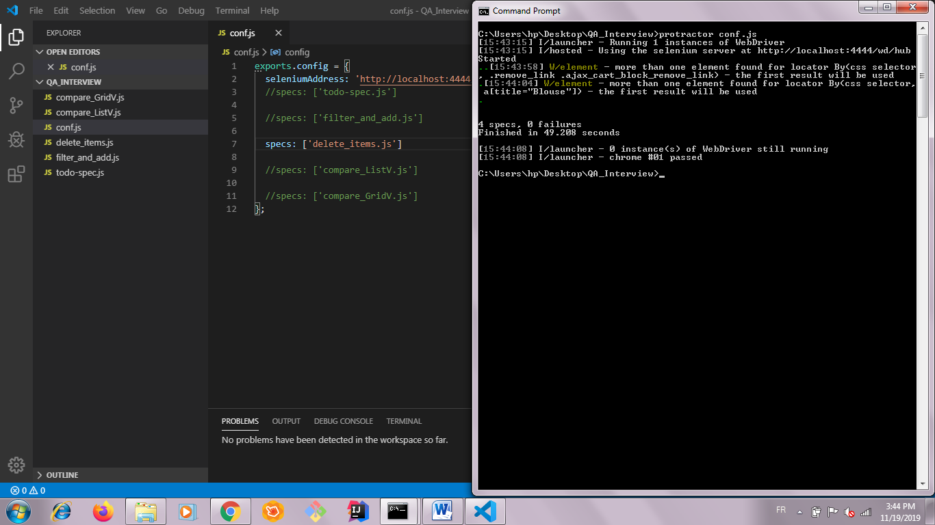

**Compare Items from List View.**

* If the user adds more than 3 items to compare, a pop up message appears as follows:

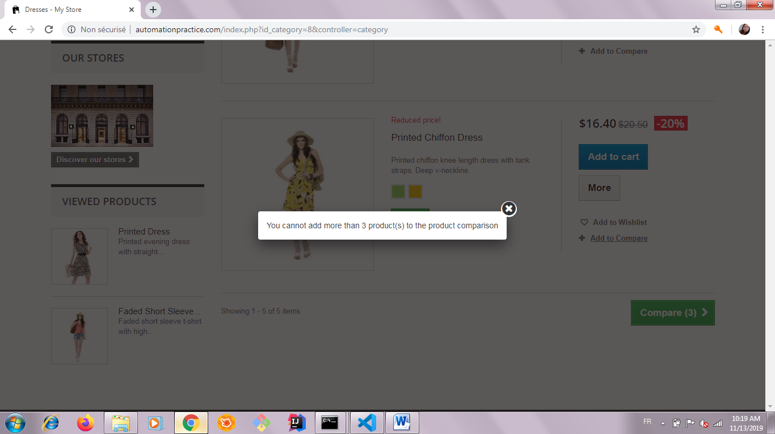

* The test related to Validate the content of Product Comparison keeps changing the value of the expected “toBe” output in each run.

**Code implementation trials:**

/*  Keeps changing the value of the expected toBe output in each run

  it('Validate the content of the Product Comparison Page', function(){

    expect(element(by.css('.comparison_feature_odd')).getText()).toBe('Compositions');

    browser.sleep(3000);

    expect(element(by.xpath(' //*[@id="product_comparison"]/tbody/tr[4]/td[1]')).getText()).toBe('Styles');

    // Item 1

    expect(element(by.xpath('//*[@id="product_comparison"]/tbody/tr[2]/td[2]')).getText()).toBe('Cotton');

    expect(element(by.xpath('//*[@id="product_comparison"]/tbody/tr[4]/td[2]')).getText()).toBe('Girly');

    expect(element(by.xpath('//*[@id="product_comparison"]/tbody/tr[3]/td[2]')).getText()).toBe('Colorful Dress');

    // Item 2

    expect(element(by.xpath('//*[@id="product_comparison"]/tbody/tr[2]/td[3]')).getText()).toBe('Viscose');

    expect(element(by.xpath('//*[@id="product_comparison"]/tbody/tr[4]/td[3]')).getText()).toBe('Dressy');

    expect(element(by.xpath('//*[@id="product_comparison"]/tbody/tr[3]/td[3]')).getText()).toBe('Short Dress');

    //expect(element(by.css('.comparison_infos .product-3')).getText()).toBe('Styles');

    //class="comparison_feature_odd comparison_infos product-3"

    //expect(element(by.tagName('td')).getText()).toBe('Colorful Dress');

  });*/

* Test terminal output:

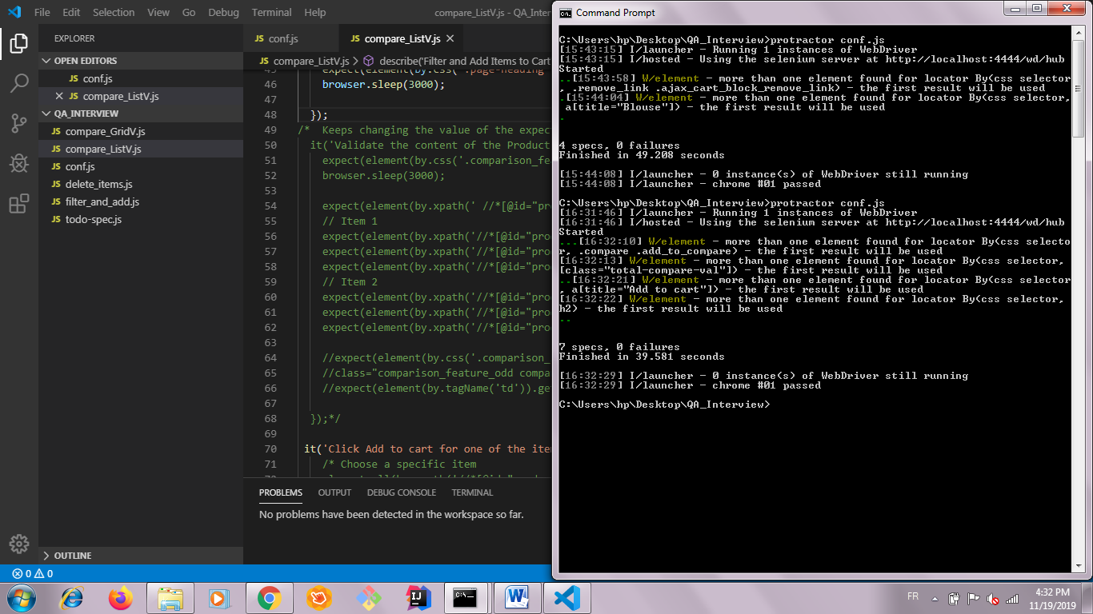

**Compare Items from Grid View.**

* Hover over and Click Add to compare button for at least 2 different items implemented test does not do it. It goes directly to the Add to compare button.

**Code implementation trials:**

// Hover over and Click Add to compare button for at least 2 different items

    /*browser.actions().mouseMove( element(by.css('a[title="Printed Dress"]')).click()).perform();

    expect(element(by.css('a[title="Printed Dress"]')).isDisplayed()).toBeTruthy();

    browser.sleep(1000);

    expect(element(by.css('.add_to_compare')).getText()).toBe('checked');

*/

* Terminal output:

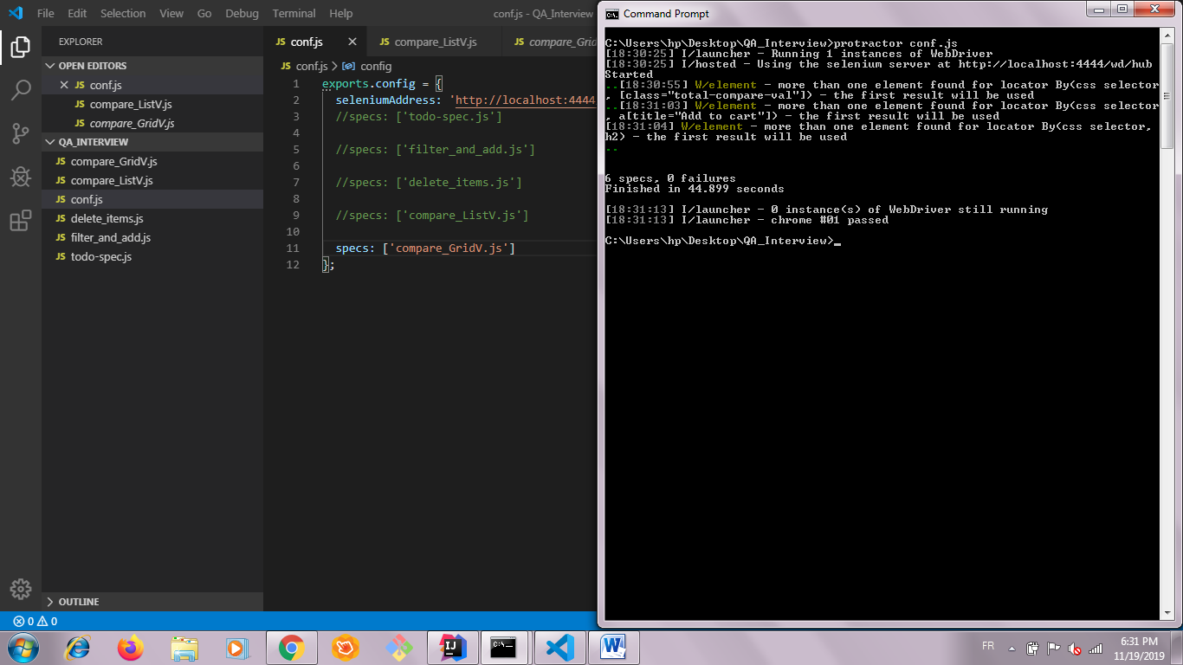

**General comments .**

* If the user clicks on Shop now or 3 Days or Only online:

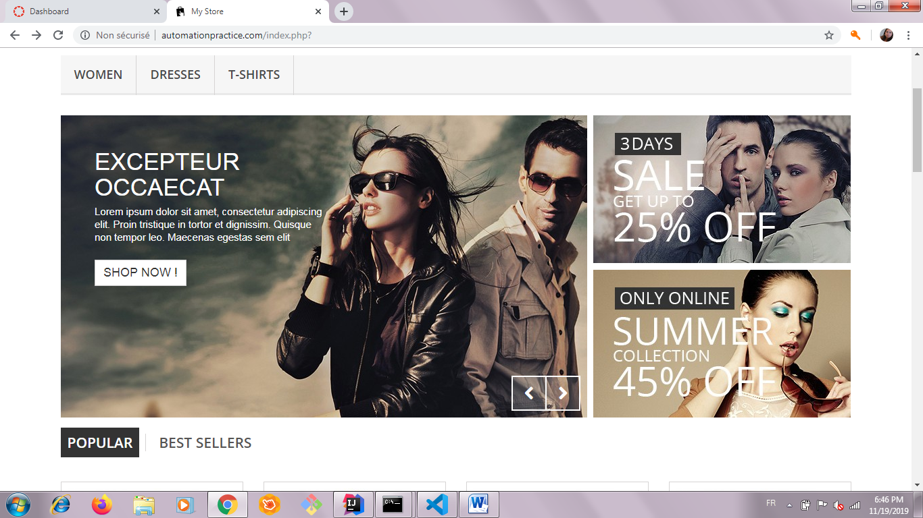

The following link loads: <https://www.prestashop.com/fr?utm_source=v16_homeslider>

* Same link loads when clicking on one of the below options:

